HSTNS-PL14 ( ou PL18 )

https://www.instructables.com/id/How-to-Convert-a-File-Serve-Power-Supply/

http://www.rcuniverse.com/forum/rc-car-general-discussions-179/11640652-server-power-supply-hp-dps-750rb.html?styleid=7

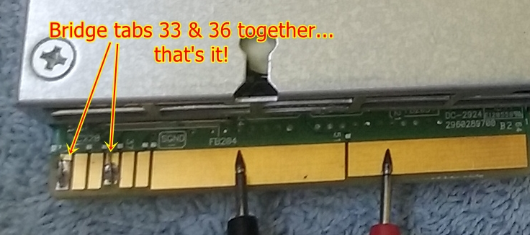

Voltage adjustement :

https://on5vl.org/alimentation-petit-prix/

Modification pour 13,8V :

